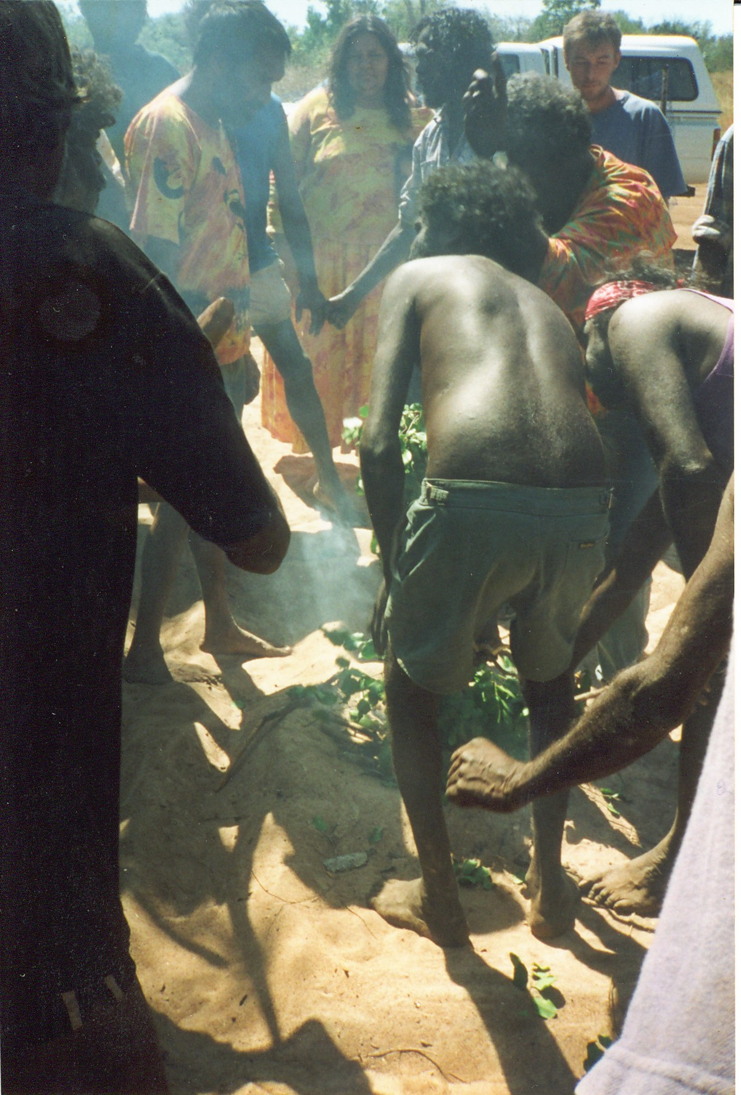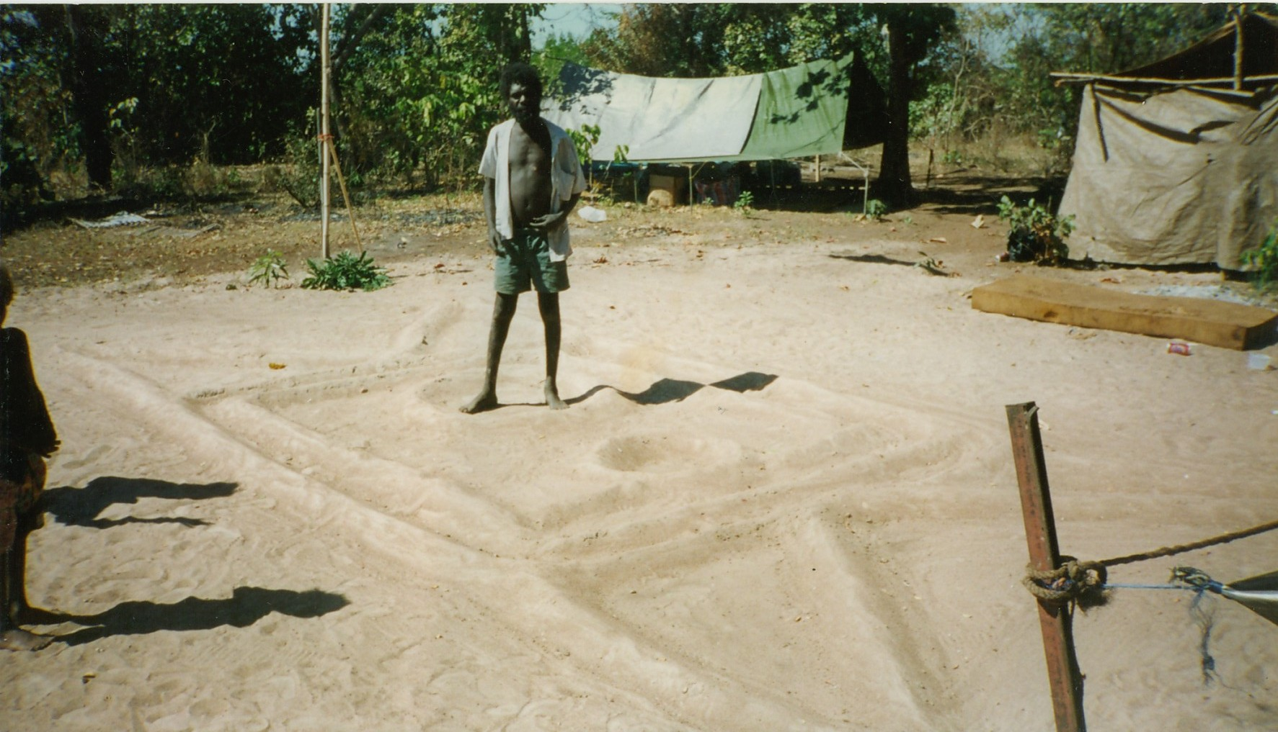

Months later, smoking and cleansing ceremonies were held at Fish Camp.

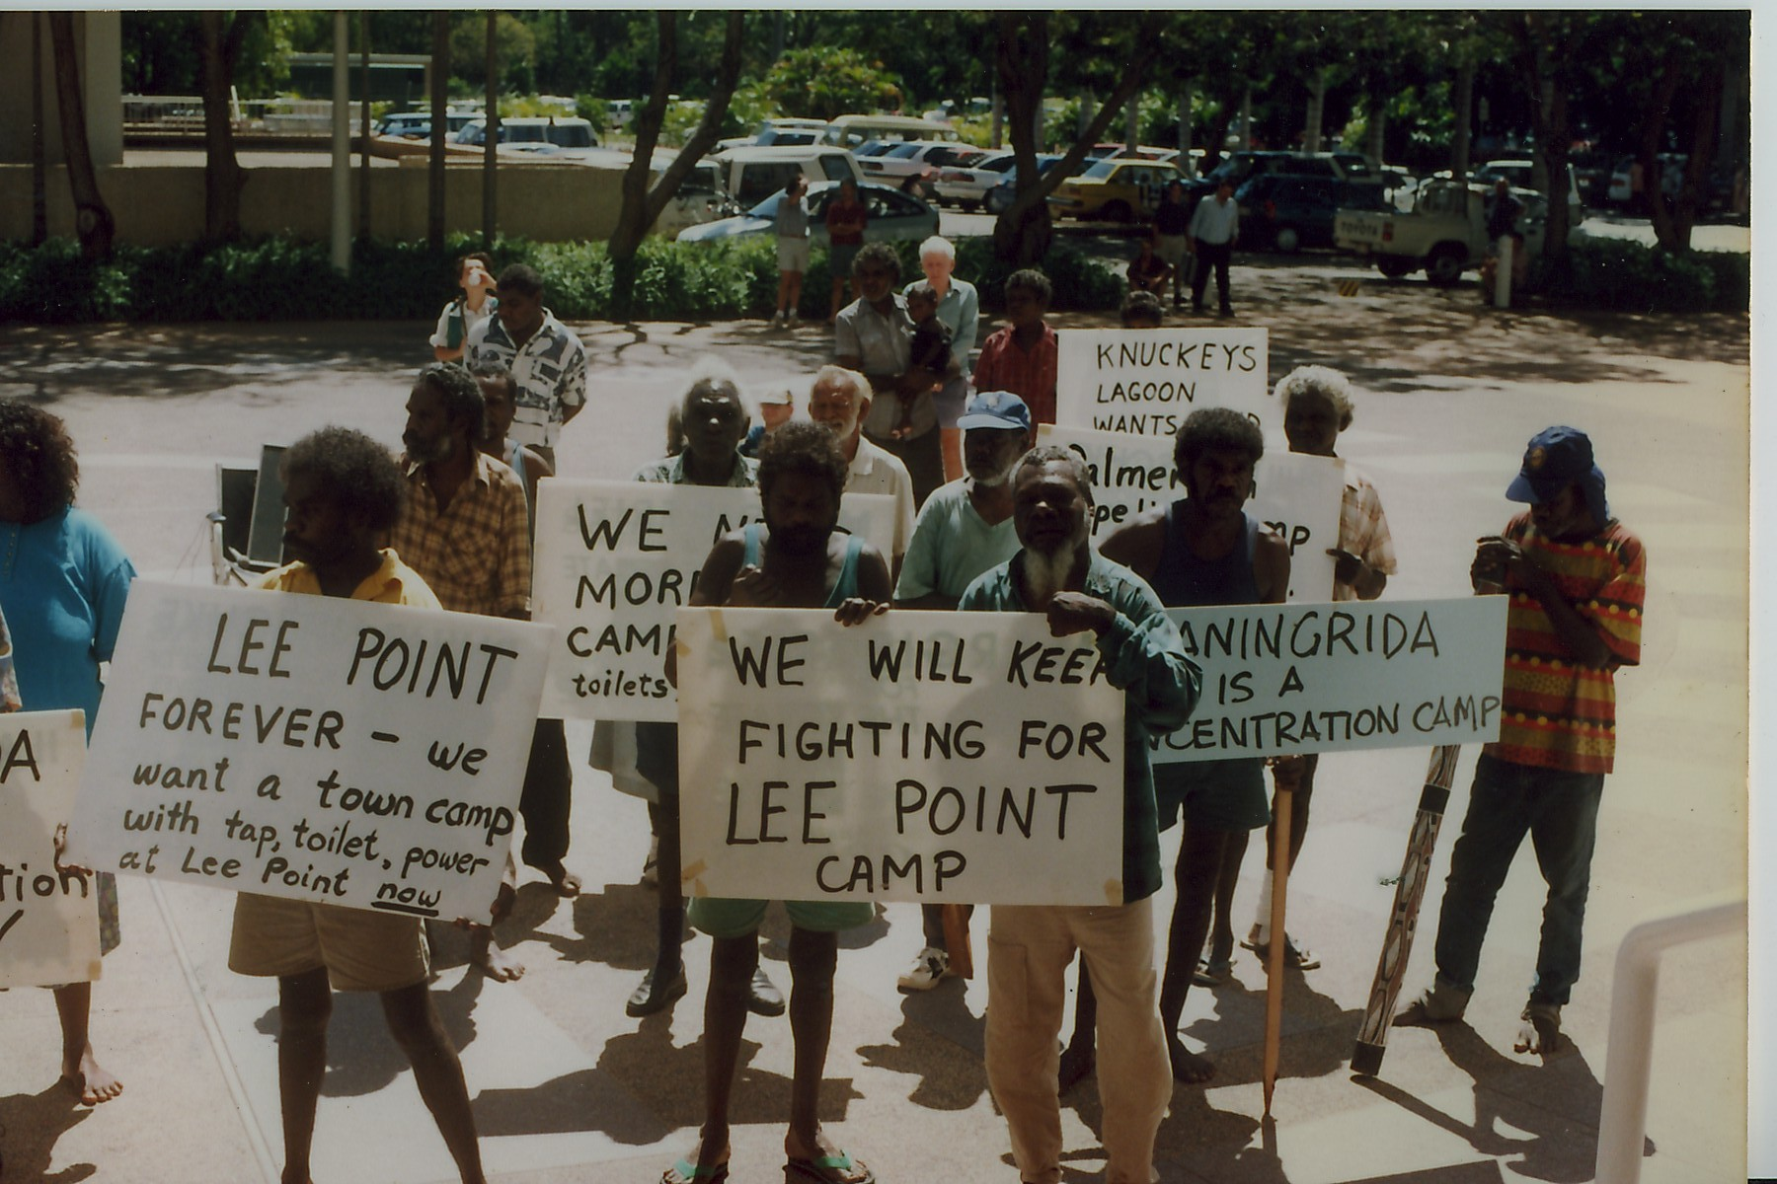

Protesters marched to Parliament House with a petition signed by over fifty homeless Aboriginal people camped around Darwin.

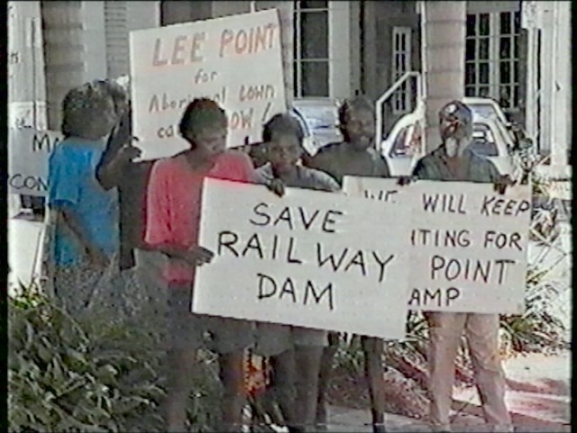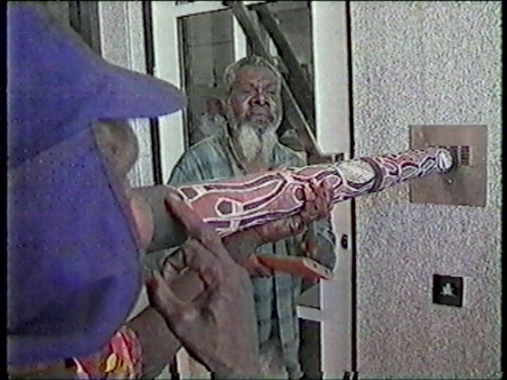

They were not allowed inside, so they blew a didgeridoo tune through the intercom.

